LEGISLATIVE MEMORIAL SCHOLARSHIP ASSOCIATION NEWSLETTER
February 2013

Sen. Emily Cain, Co-Chair  Dawna Lopatosky, Treasurer | 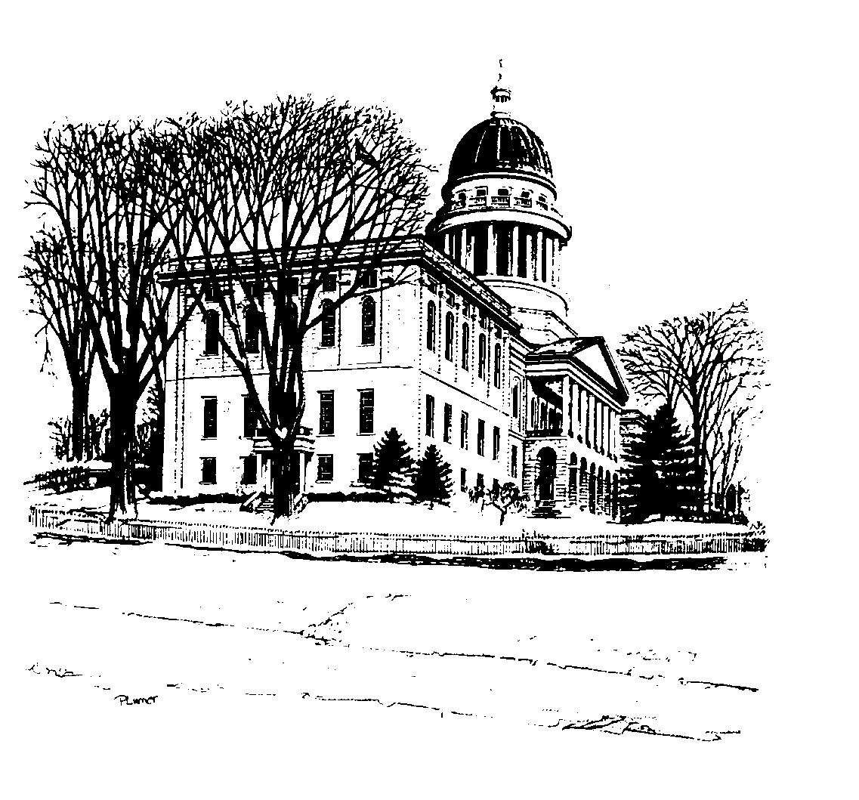 | Rep. Stacey Guerin, Co-Chair  Alison Ames, Secretary

Background
The Legislative Memorial Scholarship Fund was established in 1995 in memory of all those who have served the Maine Legislature. The annual Scholarship Auction is the primary source for raising funds and is a successor to the Gould-Michaud Scholarship Auction. The Gould-Michaud Scholarship Fund was established on behalf of the late Representative Stephen Gould (R-Stillwater) and David Michaud, House Page, who was killed by a drunk driver.

The LMS fund started awarding $500 scholarships in 1997. In 2002, the awards were increased to $750 and in 2003, to $1000. Since its inception as the LMS, the fund has awarded over $210,000 to one student from each of Maine’s sixteen counties. Awards are made to Maine residents attending Maine post-secondary schools based on a variety requirements including a 300 word essay, recommendations, academic standing and need.

The 2013 awards ceremony will be held on a date TBD in May, 2013.

The Legislative Memorial Scholarship is a not-for-profit, registered as a 501(c)(3) organization and all donations are tax deductible.

Scholarship applications are available online at www.mesfoundation.com and are due by April 15th for award next year.

An auction donation form can be found online at www.maine.gov/legis/lio/LMScholar/DonationForm2013.pdf

An auction sponsorship form can be found online at www.maine.gov/legis/lio/LMScholar/AuctionSponsorshipForm.pdf

The Auction
2013 Legislative Memorial Scholarship Auction

Tuesday, March 19th Augusta Civic Center
5:00 pm Socialize * Raffle * Buffet Dinner * Bid on Silent Auction Items
6:00 pm Dinner * Live Auction Starts at 6:15
Dinner Tickets $20
Note: $20 covers the DINNER only. The auction is free to attend.

Tickets go on sale February 19th.
Tickets must be purchased no later than March 14th

Donations
Suggestions for donations: Previously we have auctioned off art, pottery, jewelry, ski passes, cottages and camps, theater tickets, kayak and gear, and Maine made products. Donation forms are available in the Clerk’s and Secretary’s offices and at the SH Kiosk.

Please Note: Donation forms and items must be turned in to the Revisor’s, Senate Democrat or House Republican Office no later than March 12th.

